**Create a React Application “eventexamplesapp” to handle various events of the form elements in HTML.**

Step1**:**Creating react app through command prompt



Step2: Creating Increment&Decrement Buttons in app.js

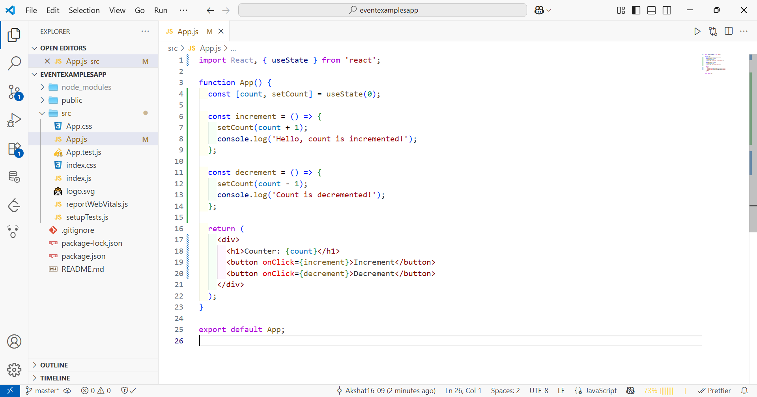

Step3: Adding "Say Welcome" Button:

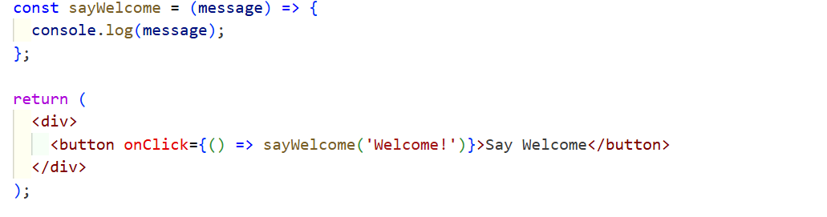

Step4: Creating a Synthetic Event Handler

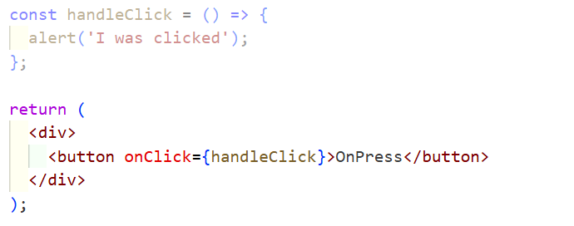

Step5: Currency Converter Component:

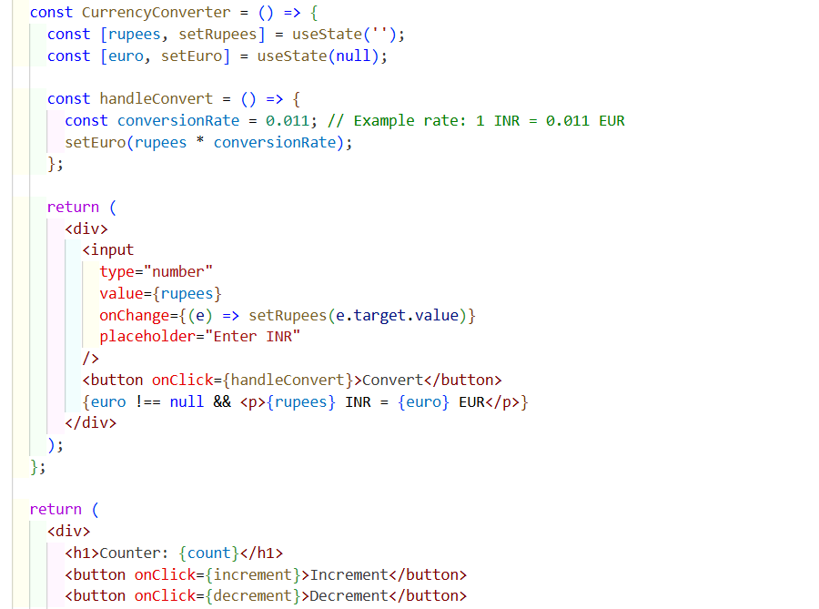

Step6:Saving and running the file using npm start in the terminal